POKHARA UNIVERSITY
Faculty of Science and Technology

Bachelor in Computer Application (BCA)
Crimson College of Technology, Butwal
Project Proposal Defense on
“ E-Commerce Platform with MCP Server Integration”
Submitted by:
Ashim Gautam
Reg.No-2022-1-53-0075 Roll. No- 22530263
Nishant Bhattarai
Reg.No-2022-1-53-0093 Roll. No- 22530281
Madan Bhandari
Reg.No-2022-1-53-0088 Roll. No- 22530276
Nishan Bhandari
Reg.No-2022-1-53-0092 Roll. No- 22530280
Table of Contents

1. Table of Contents 2
2. Introduction 3
3. Problem Statement 4
4. Objectives 6
5. Scope and Limitations 7
6. Feasibility Study 8
7. System Requirements 9
8. Methodology 10
9. Implementation Tools 14
10. Expected Outcomes 15
11. Gantt Chart 16

Chapter 1 : Introduction
This project proposes the design and development of a modern e-commerce platform that goes beyond the conventional “browse and click” shopping experience by making the store directly usable by AI agents. Instead of relying only on a human navigating menus and filling out forms, the platform exposes an MCP (Model Context Protocol) server so that AI assistants can search products, manage carts, place orders, and track deliveries on a user's behalf through a conversational interface.
E-commerce has become the dominant channel through which people shop, compare products, and make purchase decisions. However, most existing platforms are built exclusively for human interaction: users must open a browser, manually search for items, apply filters, click through several pages, and fill out multi-step checkout forms. This design assumes that the person interacting with the system is always a human operating a mouse and keyboard, and it does not account for the rapid rise of AI assistants and autonomous agents that people now use to complete everyday tasks.
Large language model (LLM) based assistants are increasingly capable of carrying out multi-step tasks on a user's behalf, but they can only do so reliably if the underlying systems expose safe, well-defined ways to interact with them. Anthropic's Model Context Protocol (MCP) is an open standard that lets an AI model connect to external tools and data sources through a structured server, rather than by scraping a website or guessing at hidden APIs. By building an MCP server around the e-commerce platform's core operations, an AI agent can be granted controlled, auditable access to actions such as searching inventory, adding items to a cart, applying a coupon, checking out, and checking order status.

1.Why MCP Instead of a Traditional API
A conventional REST or GraphQL API is built for a specific frontend that already knows each endpoint's shape, required parameters, and business rules. An AI model has no such prior knowledge it needs a self-describing interface it can reason about at runtime. MCP solves this by standardizing three things: Tools (discrete callable actions such as search_products or add_to_cart, each with a machine-readable schema), Resources (structured data the model can read, such as a product catalog or a user's order history), and Prompts (reusable instruction templates that guide the model on how to use the tools correctly). An MCP Server exposes these tools/resources/prompts, while an MCP Client embedded inside the AI service discovers and invokes them on behalf of the model. This is the key architectural difference from a traditional API: instead of a human developer hard-coding calls to fixed endpoints, the AI model itself decides, at conversation time, which tool to call and with what arguments, based on the tool descriptions the server advertises.

2.AI Agent vs. Chatbot
A chatbot is typically a conversational front end that answers questions or follows a fixed dialogue script; it does not take independent action on external systems. An AI agent, by contrast, can plan a sequence of steps, decide which tool to call at each step (tool calling / function calling), observe the result, and adjust its next action accordingly for example, searching for laptops, comparing the results against the user's budget, and only then deciding whether to add an item to the cart or ask a follow-up question. This project's AI assistant is therefore designed as an agent: it reasons over the user's request, calls one or more MCP tools to gather information or perform actions, and continues the loop until the user's task is complete.
This project therefore aims to build a dual-interface e-commerce system: a conventional, responsive web storefront for regular browsing, and an MCP-enabled backend that allows AI shopping assistants to perform the same operations conversationally, securely, and with proper authentication and permission scoping. The result is a platform that is equally usable by a person clicking through pages and by an AI agent acting on that person's instructions.

Chapter 2 : Problem Statement
Traditional e-commerce websites are designed exclusively around human-facing interfaces. This creates several concrete problems as AI-driven shopping assistants become more common:
- There is no standardized, secure way for an AI agent to search products, manage a cart, or place an order; agents that attempt this today must resort to fragile web-scraping or unofficial API calls.
- Direct database or raw API access by an AI agent creates serious security risks, since there is no clear permission boundary between what an agent is allowed to do and what a human administrator can do.
- Users who want a conversational shopping experience (“find me a pair of running shoes under Rs. 5000 and order the best-rated one”) currently have no reliable way to delegate that multi-step task to an assistant.
- There is no audit trail or controlled action log when an AI agent performs a transaction, making it hard to verify or roll back agent-driven actions.
- Existing store platforms tightly couple business logic with the human UI, so there is no clean, reusable layer that both the website and an AI agent can call into.
This project addresses these problems by introducing an MCP server as a formal integration layer between AI agents and the e-commerce backend, alongside the usual web storefront.

Chapter 3 : Objectives
- To design and develop a fully functional e-commerce web platform with product catalog, cart, checkout, and order tracking.
- To implement an MCP server that exposes secure, well-documented tools (e.g. search_products, get_product_details, add_to_cart, check_order_status, check_inventory) for use by AI agents.
- To build a Python-based AI service that hosts the MCP client, calls an LLM API, and reasons step-by-step to fulfil user requests (understand requirement → search → compare → recommend → act).
- To enforce authentication and permission scoping so that AI agents can only perform actions authorized by the logged-in user, never accessing the database directly.
- To build a conversational shopping assistant that can understand natural-language requirements, compare products, explain its recommendations, and manage the cart on the user's behalf.
- To maintain an audit log of all actions performed through the MCP server for transparency and traceability.
- To provide an admin dashboard for inventory, order, and user management.

Chapter 4: Scope and Limitations

Scope
- User registration, login, and profile management.
- Product catalog with search, category filters, and product detail pages.
- Shopping cart, coupon application, and checkout with order summary.
- Order tracking and order history for users.
- Admin dashboard for product, inventory, and order management.
- MCP server exposing a defined set of tools for AI agents: Search Products, Product Details, Add to Cart, Order Status, and Inventory Check.
- A dedicated Python/FastAPI AI service that hosts the MCP client and calls an LLM API (OpenAI / Gemini / Claude) to power the shopping assistant.
- Chat-based AI shopping assistant that consumes the MCP tools to search, compare, recommend, and manage the cart conversationally.
- Basic action-logging/audit trail for agent-initiated operations.

Limitations
- Single-vendor store only no multi-vendor marketplace functionality.
- No dedicated native mobile application; the platform will be a responsive web application only.
- AI interaction is limited to text-based chat; voice-based ordering is out of scope.
- Payment integration will use a sandbox/test payment gateway rather than a live production gateway.
- No machine-learning-based recommendation engine; product suggestions will use simple rule-based logic due to time constraints.

Chapter 5 : Feasibility Study

Technical Feasibility
The system will be built using mature, well-documented technologies React/Next.js with TypeScript for the frontend, Node.js with Express/NestJS for the core backend, PostgreSQL with Prisma ORM for structured data storage, a separate Python/FastAPI AI service to host the MCP client and call the LLM API, and the official MCP SDK to expose agent-callable tools from the MCP server. The team has prior coursework experience with JavaScript/TypeScript full-stack development, and the MCP SDK provides clear scaffolding for defining tools, resources, and authentication, making the integration technically achievable within the project timeline.

Operational Feasibility
For regular users, the storefront works exactly like any familiar e-commerce site, requiring no special training. For users who choose to use the AI shopping assistant, the chat interface is designed to be conversational and forgiving of natural language, so no technical knowledge is required. Administrators will use a simple dashboard for catalog and order management, similar to tools they may already be familiar with.

Economic Feasibility
All core technologies used in this project React, Node.js, PostgreSQL, Prisma, FastAPI, and the MCP SDK are open source and free to use. Hosting can be done on low-cost cloud tiers suitable for a student project, and the payment gateway will run in sandbox mode during development, incurring no real transaction costs. Overall development cost is limited mainly to optional cloud hosting and LLM API usage during testing.

Chapter 6 : System Requirements

Hardware Requirements

Component | Specification
Processor | Intel Core i5 (or equivalent) or higher
RAM | 8 GB minimum (16 GB recommended for local LLM testing)
Storage | 256 GB SSD (recommended for faster build/dev tooling)
Server (deployment) | Minimum 2 vCPU, 4 GB RAM cloud instance

Software Requirements

Component | Specification
Operating System | Windows 10/11, macOS, or Linux
Code Editor / IDE | Visual Studio Code
Frontend Runtime | Node.js (LTS version), npm, TypeScript
AI Service Runtime | Python 3.11+, FastAPI, uvicorn
Database | PostgreSQL, Prisma ORM
Version Control | Git and GitHub
API Testing | Postman
AI/LLM Access | OpenAI / Gemini / Claude API with MCP SDK
Containerization | Docker, Docker Compose (for running frontend, backend, AI service, and database together)

Chapter 7 : Methodology

Requirement Collection
Requirements will be gathered through informal interviews with small online sellers and frequent online shoppers, review of existing e-commerce platforms and their limitations for AI-agent use, and a short survey among classmates regarding their expectations from a conversational shopping assistant. Existing documentation on the Model Context Protocol will also be studied to correctly scope which store operations should be exposed as agent-callable tools.

System Design
Once requirements are finalized, the system will be modeled using standard analysis and design tools:
- Data Flow Diagrams (DFD) context-level and level-1 diagrams to show how data moves between the user, the storefront, the MCP server, and the database.
- Entity-Relationship (ER) Diagram to design the database schema covering Users, Products, Carts, Orders, and Agent Action Logs.
- UML Use Case Diagram to define the actions available to each actor: Customer, Admin, and AI Agent.
- Sequence Diagram to illustrate the step-by-step flow of an AI agent calling an MCP tool (e.g. search → add to cart → checkout) and how the server validates and executes each step.

- Iterative Model
The development of this project will follow an iterative software development model, where the system is built and improved through a series of planned iterations. Each iteration focuses on implementing a specific set of features and produces a functional working increment of the application. For example, the first iteration will develop the product catalog, followed by the shopping cart and checkout functionality in the second iteration. Subsequent iterations will implement the MCP tools, integrate the AI-powered chat assistant, and add any remaining features. After each iteration, the completed functionality will undergo testing, evaluation, and refinement based on the results before moving on to the next phase. This approach helps identify issues early, supports continuous improvement, reduces development risks, and ensures that the final system is reliable, user-friendly, and aligned with the project requirements.

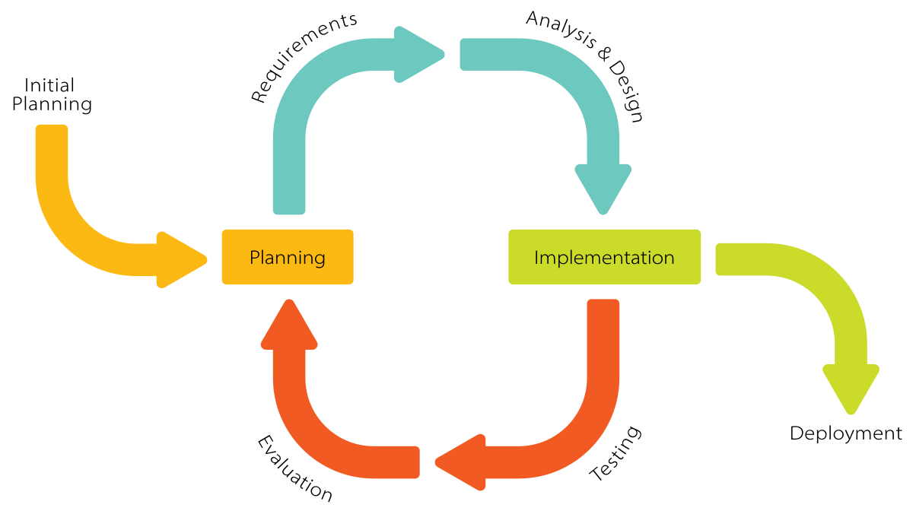

Figure : Iterative Model

System Architecture
The diagram below shows how a request flows through the platform: the user talks to the React/TypeScript frontend, which calls the Node.js backend; the backend either reads/writes PostgreSQL directly (via Prisma ORM) for normal storefront operations, or forwards AI-assistant requests to a separate Python/FastAPI AI service. The AI service calls an LLM API (OpenAI / Gemini / Claude) to reason about the request and uses an MCP Client to invoke tools exposed by the MCP Server Search Products, Product Details, Add to Cart, Order Status, and Inventory Check which in turn call back into the Node.js backend to actually perform the action, keeping the AI service and the LLM completely separate from direct database access.
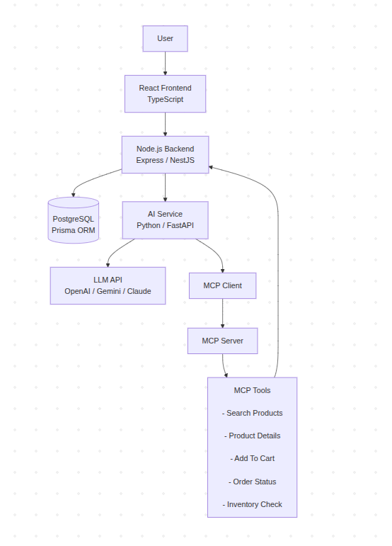
Figure: Proposed system architecture request flow from user to MCP tools.

MCP Server Development Approach
The MCP server will be developed as a thin, well-defined layer on top of the existing backend services rather than a replacement for them:
- Tools: each backend capability the AI is allowed to use (search_products, get_product_details, add_to_cart, check_order_status, check_inventory) will be exposed as a named MCP tool with a strict input/output schema.
- Resources: read-only structured data such as product listings or a user's order history will be exposed as MCP resources the model can fetch for context.
- Prompts: reusable prompt templates will guide the model on how to phrase recommendations and when to ask clarifying questions before acting.
- Communication: the MCP server will call into the same Node.js/Express/NestJS backend services (and, transitively, PostgreSQL through Prisma) that the web frontend uses, so business logic and validation rules are written once and reused by both humans and AI agents.
- Authentication & Permissions: every tool call will carry the requesting user's session/JWT token, and the server will re-validate that the action is permitted for that user before executing it the AI agent is never given a standing credential broader than the end user's own permissions.

AI Agent Workflow
For a request such as “find me a laptop for programming under $1000,” the agent follows a repeatable loop: (1) parse the user's requirement into structured criteria (budget, category, use-case), (2) call the search_products tool with those criteria, (3) call get_product_details on the top candidates to compare specifications, (4) generate a natural-language explanation of why particular products fit the requirement, and (5) on user confirmation, call add_to_cart. Each step's tool result is fed back into the model's context before it decides on the next action, which is the core “observe → decide → act” loop that distinguishes an agent from a simple chatbot.

Security Considerations
Because an AI agent's actions can have real-world effects (adding items to a cart, placing an order), the architecture treats the AI service as an untrusted caller that must go through the same authorization checks as any other client:
- The AI service and the LLM never connect to PostgreSQL directly; all data access happens through the Node.js backend's existing, already-validated service layer.
- Every MCP tool call is scoped to the authenticated user's permissions, so an agent cannot view or modify another user's cart, orders, or profile.
- Sensitive or irreversible actions (checkout, payment) will require an explicit confirmation step from the user before the agent is allowed to execute them.
- All tool invocations are logged with the tool name, arguments, and the user on whose behalf they were called, so any AI-driven action can be audited or reversed if needed.
- Input validation is applied both when the LLM constructs a tool call and again inside the tool handler itself, so a malformed or adversarial request from the model cannot bypass backend business rules.

Chapter 8 : Implementation Tools
Layer | Tool / Technology
Frontend | React / Next.js, TypeScript
Backend | Node.js, Express / NestJS
Database | PostgreSQL, Prisma ORM
AI Service | Python, FastAPI
LLM API | OpenAI / Gemini / Claude
MCP Layer | MCP SDK MCP Client (inside AI service) and MCP Server
MCP Tools Exposed | Search Products, Product Details, Add to Cart, Order Status, Inventory Check
Authentication | JWT (JSON Web Tokens)
Payment Gateway | Stripe (sandbox/test mode)
Infrastructure | Docker, Docker Compose
Version Control | Git, GitHub

Chapter 9 : Expected Outcomes
By the end of this project, the following deliverables are expected:
- A fully functional, responsive e-commerce web application with catalog browsing, cart, checkout, and order tracking.
- A working MCP server exposing a documented set of tools that allow an AI agent to search products, manage a cart, check out, and track orders on behalf of an authenticated user.
- A conversational shopping assistant demo that understands a natural-language requirement (e.g. “find me a laptop for programming under $1000”), searches and compares products, explains its recommendation, and adds the selected item to the cart on confirmation.
- A secure authentication and permission-scoping mechanism ensuring AI agents act only within a user's authorized boundaries and never access the database directly.
- An admin dashboard for managing products, inventory, and orders.
- A basic audit log of agent-initiated actions for transparency and traceability.
- A Dockerized deployment (frontend, backend, AI service, and database running via Docker Compose) for consistent local and demo environments.
- Complete project documentation, including DFD, ER diagram, UML use case and sequence diagrams, and MCP tool specifications, that could serve as a reusable template for future AI-agent-ready e-commerce projects.

Chapter 10 : Gantt Chart
The project is planned over a 10-week timeline as shown below:
Phase | Wk1 | Wk2 | Wk3 | Wk4 | Wk5 | Wk6 | Wk7 | Wk8 | Wk9 | Wk10
Proposal Defense
Literature Review
Requirement Analysis
System Design (DFD/ER/UML)
MCP Server Development
Frontend Development
AI Agent Integration & Testing
System Testing
Final Documentation

